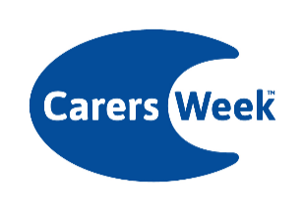Carers Week 2025 supporter pack

Social media suggested copy

Get involved in #CarersWeek 2025!
This year’s theme is Caring About Equality and from 9-15 June we are asking everyone to join us in saying ‘we care about equality for carers’.
Find out more here 👉 www.carersweek.org
--
There are lots of ways to get involved in #CarersWeek!
Visit www.carersweek.org to find out more about how you can take part in loads of great activities and say we want greater equality for unpaid carers.
--
We’re proud to be supporting #CarersWeek!
Find out more here 👉 www.carersweek.org
--
Join us in saying ‘We care about equality for carers’ this #CarersWeek
Get involved 👉 www.carersweek.org
--
Been busy planning your activity for #CarersWeek?
Add your activity here and find out what else is going on up and down the country: www.carersweek.org
--
Social media graphics
Graphics for use on social media can be downloaded here.

